EC Member 2024-2026
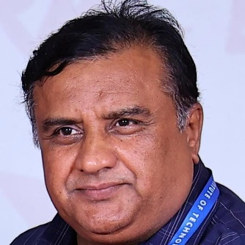 | Dr. C V Ravishankar, Chairman  Contact Address: 63 IInd Main Road, Honnappa Layout, Mallatha Halli,  Bangalore-560 056  Contact No.: (M) 99861 55861  E-mail: cvravishankar@yahoo.com  chairman@ietebangalore.org
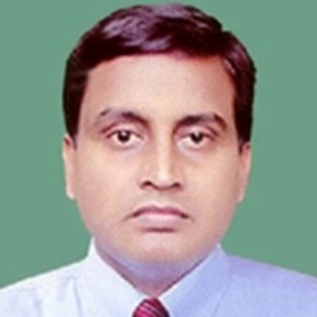 | Dr. C P Dwivedi, Immediate Past Chairman  Contact Address: C-130 North 5th Lane, ITI, Township, Doorvani Nagar,  Bangalore-560 016  Contact No.: (M) 94830 09259  E-mail: dwivedichandra@yahoo.com

Prof. Sharada P N, Hon. Secretary

Contact Address: #372 3rd B Main Road, 2nd Phase Manjunath Nagar, Rajaji Nagar, Bangalore-560 010
Contact No.: 90367 79271
E-mail: sharadapatagupi@gmail.com

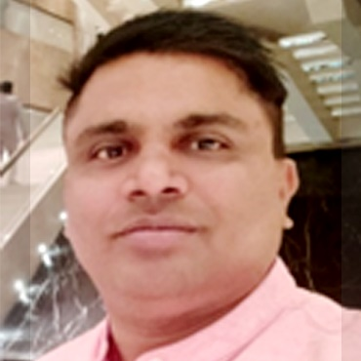 | Sri. Ranjeet Kumar, Hon. Treasurer  Contact Address: #84/3 1st Floor, Chamundi Nagar Dasadpa Garden, R T Nagar HMT Layout,  Bangalore-560 032  Contact No.: (M) 88846 09094  E-mail: blr.ranjeet@gmail.com
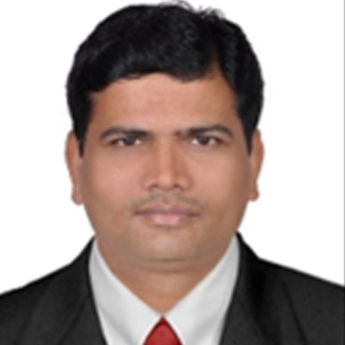 | Dr. D G Rao, Vice-Chairman  Contact Address: 301 RAMD LRDE, DRDO,  Bangalore-560 093  Contact No.: (M) 94484 55690  E-mail: raogovind2@gmail.com
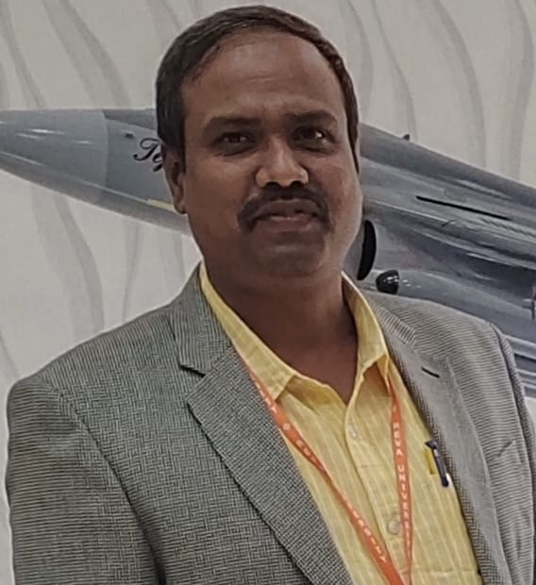 | Dr. K M Sudharshan, Vice-Chairman  Contact Address: No.228, Belaku, Gnana Bharathi Layout, 1st Block Kengeri, Bangalore-560 059  Contact No.: 98866 76136  E-mail: kmsudharshan@gmail.com
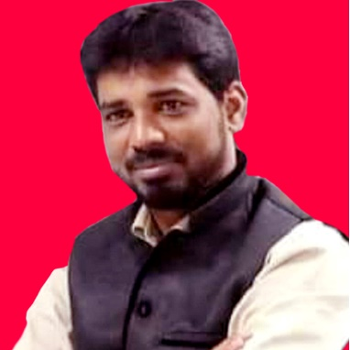 | Sri. S Purushothaman, Joint Secretary  Contact Address: CATF ISITE URSC, ISRO Karthik Nagar, Bangalore-560 037  Contact No.: 90085 65425  E-mail: purusho@ursc.gov.in, psthaman11@gmail.com
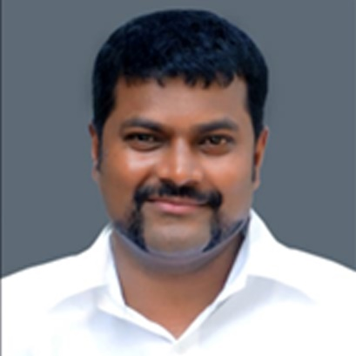 | Dr. Keshava Murthy, EC Member  Contact Address: #14 Lakshmi Nivasa, 1st Main, 3rd Cross, Cholanagar R T Nagar Post, Bangalore-560 032  Contact No.: 98446 62014  E-mail: keshavamurthy_s@yahoo.com
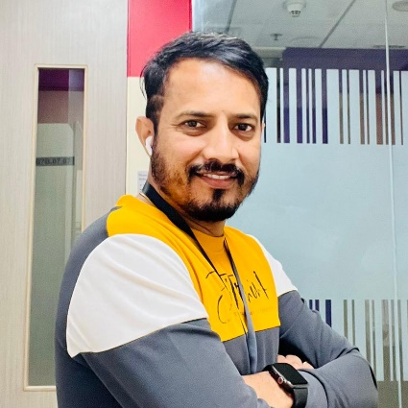 | Sri. Harsha A, EC Member  Contact Address: #304 Whitepearls, Jayapragathi Layout, Kudlu, Bangalore-560 068  Contact No.: 99001 53326  E-mail: harsha6@gmail.com
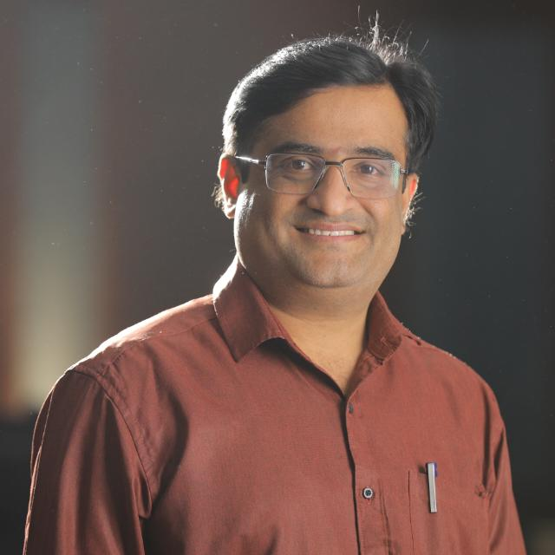 | Dr. K N Madhusudhan, EC Member  Contact Address: 'ANARGHYA' # 208/3 2nd Cross, Ankanna Reddy Layout, Dodda Banaswadi, Bangalore-560 043  Contact No.: 98454 09693  E-mail: krgirimadhu@gmail.com
Dr. S D Sudarsan EC Member
Contact Address: J703 Brigade Metropolis, Garudacharpalya, Mahadevpura Po,
Bangalore- 560 048
Contact No.: 99720 98457
E-mail: sds@cdac.in

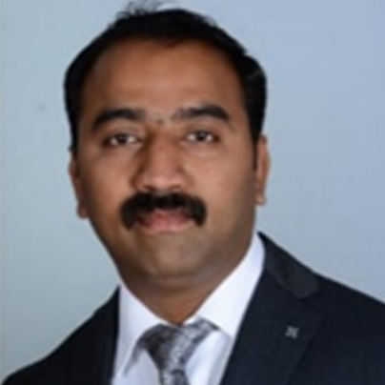 | Dr. S G Shivaprasad Yadav, Co-Opted Member  Contact Address: No 566 3rd Main, Bhuvaneshwari Nagar, R T Nagar Post, Bangalore-560 032  Contact No.: 98805 00861  E-mail: shivaspy@gmail.com
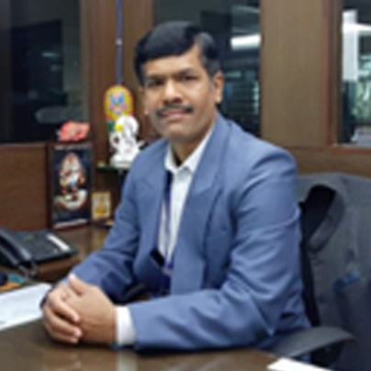 | Prof. Prakasha G, Co-Opted Member  Contact Address: # 2D-802, DOS-ISRO Housing Colony, Jalahalli, Bengaluru-560 031  Contact No.: 99165 52711  E-mail: sriven_prakasha@yahoo.com
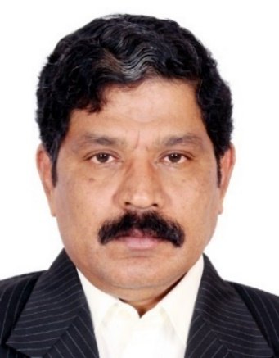 | Sri. G Ramesh, Governing Council Member  Contact Address: No K-003, Keerthi Harmony Apartment, Near Koshys Hospital & Raghavendra  Circle, T C Palya Main Road, Ramamurthy Nagar  Bengaluru-560 016  Contact No. :(M) 96633 99311  E-mail : rgieteb@gmail.com, gramesh@ursc.gov.in
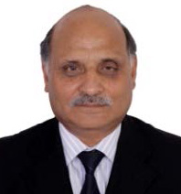 | Dr. D C Pande, Governing Council Member  Contact Address: D-106 Purva Seasons, Kaggadaspura Main Road, C V Raman Nagar, Bengaluru-560 093  Contact Numbers :(M) 94490 48858  E-mail: pande_dc@hotmail.com
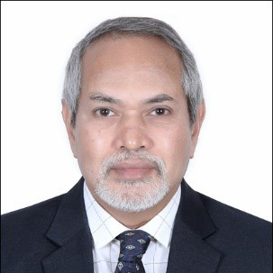 | Dr. M H Kori, Governing Council Member  Contact Address: #520,11 A Cross, R M V Extn Sadashivanagar, Bengaluru-560 080  Contact No.: 93425 93876  E-mail: mhkori@gmail.com
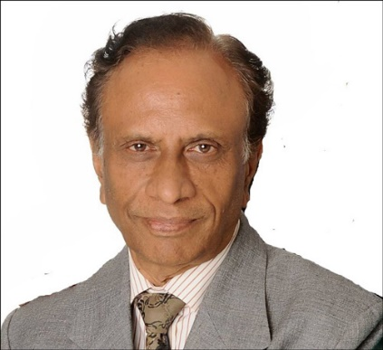 | Sri. C Satyanandan, Governing Council Member  Contact Address: 130 Garden Villas, Nagarbhavi Road, Maruthwagar, Bengaluru-560 072  Contact No.: (M) 98804 71692  E-mail: satyanandanc@yahoo.com

Sri. R Harikumar, Governing Council Member
Contact Address: A001/B402, Sterling Park, Sanjeevini Nagar, Bangalore-560 092
Contact No.: 90193 57017
E-mail: harikumarr@bel.co.in

